Dumpton School

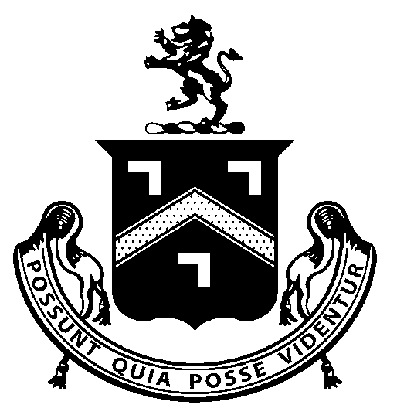

COVID-19
POLICY

January 2021

Executive Summary

This document sets out the school policy on actions to be taken in response to the Covid-19 pandemic. It should be noted that any compelling advice issued by central government will take precedence over the actions set out in this policy.

Dumpton School recognise that for many of the pupils, the routine and structure of school is extremely important for their wellbeing, so the school aims to maintain normal routines as much as possible. Some of the additional measures in this policy are a continuation of our already existing health and safety policy.

Dumpton School intend to limit the risk to pupils and staff by:
- the introduction of additional personal hygiene requirements for staff and pupils as they move around the school (e.g. hand washing/sanitising - face masks will not be used);
- the cancellation of all pupil trips;
- the cancellation of staff travel – staff should not attend external events such as conferences, training or exchanges;
- the minimising of school visitors – only those deemed necessary will be allowed to come into school and
- the introduction of parental choice - school will authorise absence if parents/carers take the view that the risk to a pupil is minimised by staying away from school (for example a particularly vulnerable pupil).

The School’s policy towards staff and pupil illness will be that:
- if a member of staff or pupil shows symptoms that would require ‘self-isolation’ under the current Government guidance, they will be sent home immediately to ‘self-isolate’ and arrange a test.
- sick pay will be paid to staff who are self-isolating in line with government guidance.

School Closure

Current Government advice is during the period of national lockdown, schools and other out-of-school activities for children should allow only vulnerable children and young people and the children of critical workers to attend. All other pupils and students should not attend and should learn remotely until February half term

Responsibilities

Headmaster/Bursar
The Headmaster and Bursar are to maintain and update all parent, and staff information relating to the development of the Covid-19 pandemic with the current advice from the Government.

School Staff will:
- follow government guidance on self-isolation;
- report symptoms immediately to the Headmaster or Bursar and leave work to go home and to self-isolate while waiting for a test;
- report any concerns regarding a pupil displaying relevant symptoms.

Objectives:
- to minimise the risk to pupils and staff during the Covid-19 pandemic;
- to carefully consider and implement ongoing Government advice;
- to maintain full awareness of the vulnerability of a large proportion of our pupils and to always act accordingly and
- to maintain full awareness of the fact that for many of our pupils, the routine and structure of school is extremely important for their wellbeing, and aim to maintain as normal a routine as much as possible.

Hygiene Precautions
Pupils and staff will be required to follow the government advice on regular hand washing as being the best method of avoiding transmission of the virus. Hand sanitiser and tissues will be available in school. Signs and posters will be used to remind staff and pupils of the above. Face masks will not be worn unless explicitly advised by the Government, as this may cause unnecessary distress to some of our more vulnerable pupils.

Pupil Travel
There can be local travel on school minibuses as long as a full risk assessment has taken place.

Staff Travel
Staff should not attend external events such as conferences, training and/or information exchange visits to other schools until further notice.

Visitors to School
• General information exchange visits to school should be cancelled to minimise the exposure
of our pupils.
• Other visitors to school can be admitted provided:
- The visit is essential for the education, health or wellbeing of a the pupil
- The visit is to carry out essential maintenance on school property – non-urgent maintenance should be carried out when the pupils are not present in school.
- Visitors must follow the hand washing / sanitisation requirements.

Illness of Member of Staff or Pupil
If a member of staff or pupil becomes ill, the symptoms will be assessed against current Governmental advice. If the symptoms are consistent with a requirement to ‘self-isolate’ the member of staff or pupil will be sent home for testing.

It is recognised that the judgement about whether the symptoms are consistent with the need to self-isolate may be difficult for mild symptoms. Where it is uncertain, the school will take a cautious approach and assume that self-isolation is appropriate, unless medical advice to the contrary is obtained.

The school recognises that this is likely to result in a significant increase in staff and/or pupil absence from school, but also that this is appropriate to limit the risk to all members of school and their families.

Sick Pay
Sick pay will be allowed to staff who are self-isolating in line with the Government advice and this policy.

School Closure
Current Government advice is that blanket school closure in response to the Covid-19 pandemic is not appropriate at this time, unless re-advised by the relevant health authorities. The Headmaster in conjunction with the Chair of Governors has the discretion to close the school if in their judgement:
- the overall staffing absence level is so high that the safety of pupils cannot be guaranteed and/or
- the rate of staff or pupil illness is excessive.

Staffing Levels
The safety of our pupils while in school is our overriding priority. The varying needs of our pupils means that it is not possible to specify a simple number of staff that are needed to ensure the safety of our pupils. Our ability to ensure the safety of our pupils will be assessed daily and on a ‘per Pod’ basis and in careful consideration of the individual needs of each pupil and/or each Pod.

If in the judgement of the Headmaster, there are insufficient staff to ensure the safety of all pupils, one or more Pod may be closed for a period and the relevant pupils sent home.

Administrative Staff
It is necessary to maintain many of the administrative functions of the school, even if the school is closed. If there is significant staff absence in the administrative functions, precautions to reduce the risk of not meeting the essential requirements will be implemented. These may include for example:
- the separation of key personnel;
- staff being required to work from home.

Policy Review Date
25 January 2021.

