COVID-19: First Aid During the Pandemic
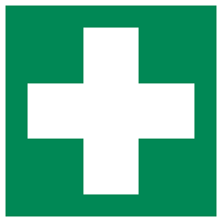
During the current COVID-19 pandemic, First Aid is as crucial as ever. Ensuring that you have the right First Aid provision for your workplace, and that your First Aiders are adequately equipped with up-to-date guidance is essential. St John’s Ambulance, Resuscitation Council (UK) and Public Health England have recently published advice for First Aiders during the pandemic, which is detailed below.

What is Coronavirus (COVID-19)?

Coronavirus disease (COVID-19) is an infectious disease caused by a newly discovered coronavirus. COVID-19 affects different people in different ways and most infected people will develop mild to moderate illness and recover without hospitalisation. The most common symptoms include fever, dry cough and/ or tiredness. However other reported symptoms include aches and pains, sore throat, diarrhoea, conjunctivitis, headache, loss of taste or smell, and/ or a rash on the skin, or discolouration of fingers or toes. Some more serious symptoms that have been reported have also included difficulty breathing or shortness of breath, chest pain or pressure and/ or loss of speech or movement.

COVID-19 spreads primarily through droplets of saliva or discharge from the nose when an infected person coughs or sneezes.

First Aid Needs Assessment

When re-opening your workplaces, you will need to assess your First Aid provision. Ensure that you have updated your First Aid Needs Assessment in line with any changes to your workplace and workforce during the pandemic.

Advice for First Aiders

Be aware of the risks to yourself and others

- When approaching a casualty there will always be a risk of cross contamination – especially when you may have to get close to the casualty to assess what is wrong or to check their breathing.
- It is always important to be aware of the risks of how this cross contamination has occurred.
- There are 2 common routes people could become infected:
  - Secretions directly transferred into the mouths or noses of people who are nearby (within 2 metres) or possibly could be inhaled into the lungs.
  - It’s possible someone may become infected by touching a person, surface or object that is contaminated with respiratory secretions, and then touching their mouth, nose, or eyes.

Keep yourself safe

- Make sure you wash your hands or if washing facilities are not available, use an alcohol (60%) gel, before and after treating a casualty.
- Ensure that you don’t cough or sneeze over a casualty when you are treating them.
- Don’t lose sight of other cross contamination that could occur that isn’t related to COVID-19.
  - Wear gloves or cover hands when dealing with open wounds
  - Cover cuts and grazes on your hands with waterproof dressing
  - Dispose of all waste safely
  - Do not touch a wound with your bare hand
  - Do not touch any part of a dressing that will come in contact with a wound.
- If you suspect the patient has COVID-19 symptoms, use PPE including disposable gloves and apron, a fluid repellent surgical mask, and face visor. Ensure PPE is put on and taken off properly and clean your hands before putting on and after removing the PPE.
- Advice on providing CPR to an adult can be found on the next pages.

Give early treatment

- The vast majority of incidents do not involve getting close to a casualty where you would come into contact with cough droplets. Sensible precautions will ensure you’re able to treat a casualty effectively.

Keep yourself informed and updated

- As this is a new disease this is an ever-changing situation and the government and NHS are continually updating their advice. Make sure that you regularly review the NHS 111, Gov.uk and Resuscitation Council websites which have specific sections on Coronavirus.

Remember your own needs

- These are challenging and uncertain times for all. In order to help others, you also need to look after your own needs. Make sure you take time to talk about your fears and concerns with someone you trust and to take time to look after yourself.

What to do after you treat someone with COVID-19 symptoms whilst providing First Aid

- If you have helped someone who was displaying symptoms of COVID-19 you do not need to go home unless you develop symptoms yourself or the individual subsequently tests positive (see ‘What happens if there is a confirmed case of coronavirus in a setting’). You must ensure that you have washed your hands thoroughly for 20 seconds after any contact with someone who is unwell.
- If that person tests positive for COVID-19, you (plus anyone else who came into contact with that person) must self-isolate for 14 days. Household members do not need to self-isolate unless the person they live with in that group subsequently develops symptoms.

Providing Paediatric Cardiopulmonary Resuscitation (CPR) During the Pandemic

- The Resuscitation Council (UK) has stated that they are aware that paediatric cardiac arrest is unlikely to be caused by a cardiac problem and is more likely to be a respiratory one, making ventilations crucial to the child’s chances of survival. However, for those not trained in paediatric resuscitation, the most important thing is to act quickly to ensure the child gets the treatment they need in the critical situation.
- For out-of-hospital cardiac arrest, the importance of calling an ambulance and taking immediate action cannot be stressed highly enough. If a child is not breathing normally and no actions are taken, their heart will stop and full cardiac arrest will occur. Therefore, if there is any doubt about what to do, this statement should be used.
- The Resuscitation Council (UK) accept that doing rescue breaths will increase the risk of transmitting the COVID-19 virus, either to the rescuer or the child/infant. However, this risk is small compared to the risk of taking no action as this will result in certain cardiac arrest and the death of the child.

Providing Cardiopulmonary Resuscitation (CPR) to an Adult During the Pandemic

CPR combines chest compressions and rescue breaths to give a person the best chance of survival following a cardiac arrest. St John’s Ambulance have updated their guidance due to the COVID-19 outbreak. Do not perform rescue breaths on the casualty. If an adult is unresponsive and not breathing normally, you still need to call 999 or 112 for emergency help and start CPR straight away.
ONE
- If you find someone collapsed, you should first perform a primary survey. Do not place your face close to theirs. If you have established from this that they are unresponsive and not breathing, you should ask a helper to call 999 or 112 for emergency help while you start CPR. If COVID 19 is suspected, tell them when you call 999 or 112. Ask a helper to find and bring a defibrillator, if available.
- Ask your helper to put the phone on speaker and hold it out towards you, so they can maintain a 2m distance.
- If you are on your own, use the hands-free speaker on a phone so you can start CPR while speaking to ambulance control.
- Do not leave the casualty to look for a defibrillator yourself. The ambulance will bring one.
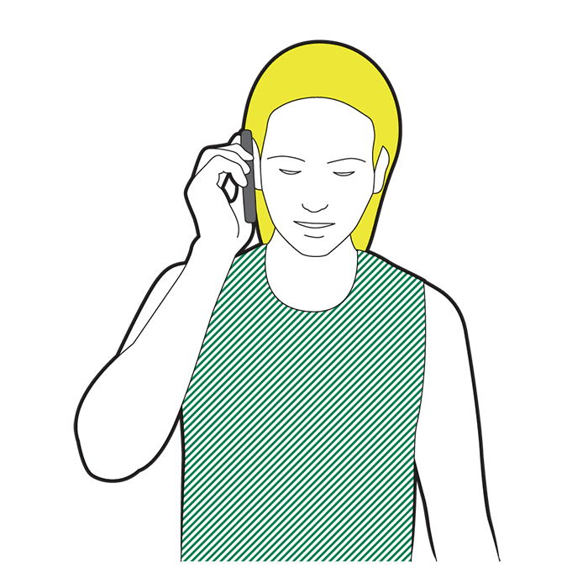

TWO
- Before you start CPR, use a towel or piece of clothing and lay it over the mouth and nose of the casualty. If you have access to any form of PPE, this should be worn.
- Start CPR. Kneel by the casualty and put the heel of your hand on the middle of their chest. Put your other hand on top of the first. Interlock your fingers, making sure they don't touch the ribs.
- Keep your arms straight and lean over the casualty. Press down hard, to a depth of about 5-6cm before releasing the pressure, allowing the chest to come back up.
- The beat of the song "Staying Alive" can help you keep the right speed.
- Do not give rescue breaths.

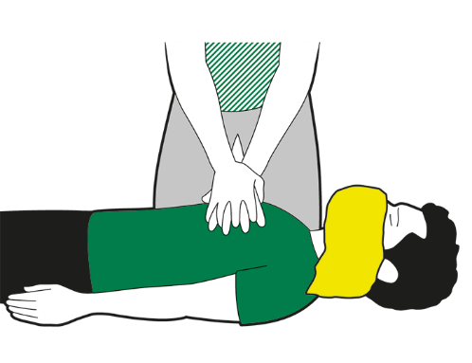

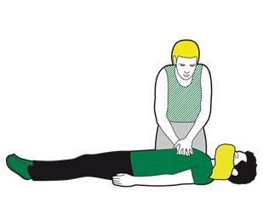
THREE
- Continue to perform CPR until:

- emergency help arrives and takes over
- the person starts showing signs of life and starts to breathe normally
- you are too exhausted to continue (if there is a helper, you can change over every one-to-two minutes, with minimal interruptions to chest compressions)
- a defibrillator is ready to be used.

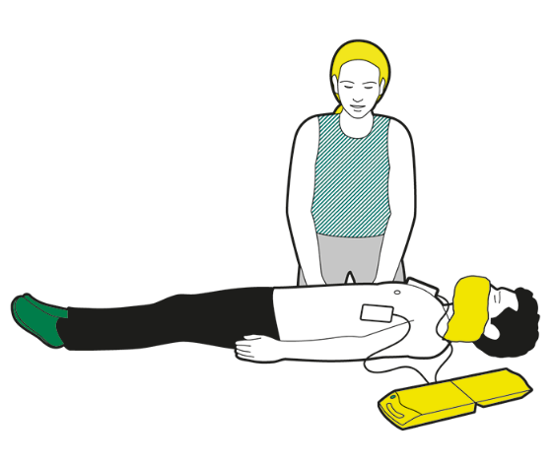

FOUR
- If the helper returns with a defibrillator, ask them to switch it on and follow the voice prompts while you continue with CPR.
- Wherever possible, the helper should keep a distance of 2m.

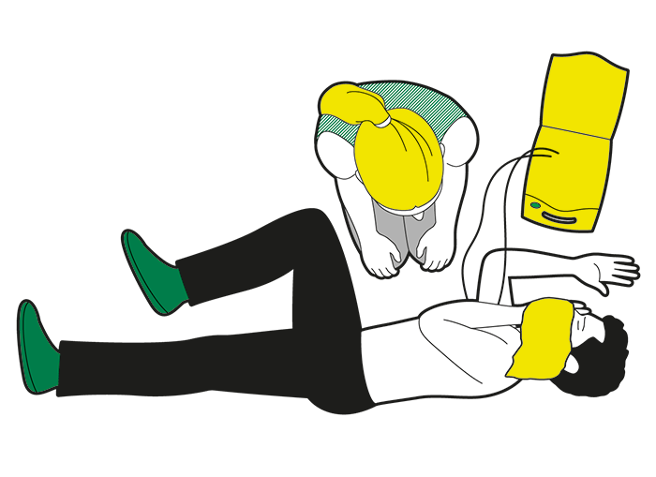
FIVE
- If the casualty shows signs of becoming responsive such as coughing, opening eyes, speaking, and starts to breathe normally, put them in the recovery position. Monitor their level of response and prepare to give CPR again if necessary.
- If you have used a defibrillator, leave it attached.

SIX
- After performing compression-only CPR, all rescuers should wash their hands thoroughly with soap and water; alcohol-based hand gel is a convenient alternative. They should also seek advice from the NHS 111 coronavirus advice service or medical adviser.

